Exercise 6 : Parameters of the Multilayer Perceptrons (2+1+0+0=3 Points)

In this exercise, you analyze the number of weights (parameters) of multilayer perceptrons. We use the notation from the lecture (e.g., slide ML: IV-104), where multilayer perceptrons have d layers, p attributes, hidden layer i with li units, and an output layer with k units.

1. Let d = 4, p = 6, l1 = 4, l2 = 4, l3 = 2, and k = 3. Draw the graph of the multilayer perceptron.

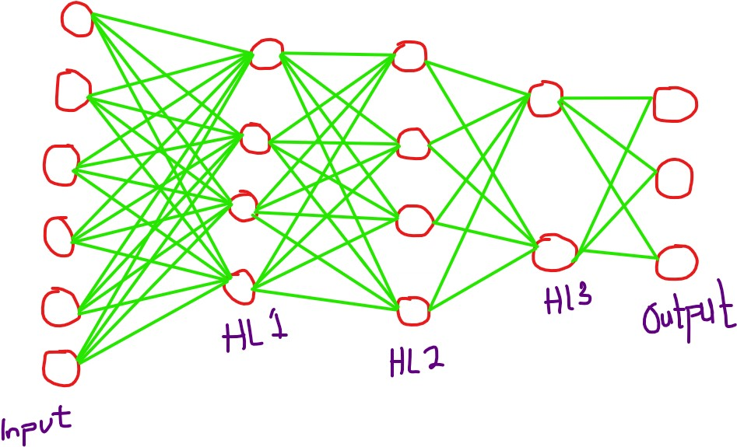

1. Calculate the number of weights in the multilayer perceptron of (a).
2. Input – HL1 = 6 x 4 = 24
3. HL 1 – HL 2 = 4 x 4 = 16
4. HL 2 – HL 3 = 4 x 2 = 8
5. HL3 – Output = 3 x 2 = 6

Total = 24 + 16 + 8 + 6 = 54

1. Calculate the number of weights in the multilayer perceptron of (a) but with each li doubled, i.e.,l1 = 8, l2 = 8, l3 = 4. Has the number of weights doubled as well?
2. Input – HL1 = 6 x 8 = 48
3. HL 1 – HL 2 = 8 x 8 = 64
4. HL 2 – HL 3 = 8 x 4 = 32
5. HL3 – Output = 3 x 4 = 12

Total = 48 + 64 + 32 + 12 = 156

The number of weights has not doubled because if the number of neurons in each layer is increased, this is a multiplication relationship that exists between the layers meaning that the weights exceed double.

1. Let f(p, l1, . . . , ld−1, k) be a function that computes the number of weights in the general case. Write down an expression for f.
2. Weights of the First layer: $p × l_{1}$
3. Weights of Hidden Layers: $l_{1} × l_{2}+ l_{2} × l_{3}+………….+ l_{d-2} × l_{d-1}$
$$=\sum_{l=1}^{d-2}{l_{i}× l_{i+1}}$$

4. Weights of Output Layers: $l_{d-1} ×k$

Hence, the resulting expression is written as

$$f= p × l_{1}+ \sum_{l=1}^{d-2}{l_{i}× l_{i+1}}+ l_{d-1} ×k$$